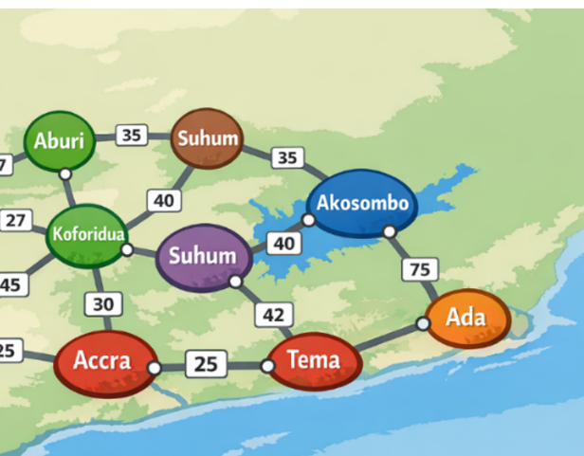
Ghana Road Transport Network Programming Challenge - 2026
Assumptions:
In this competition, you may use any ONE of the following programming languages : Python/C/C++/Java. If anything is not clear ( as is normally the case in most software development, you may seek clarification from the organizers or make your own assumptions and state those assumptions, as long as you do not change the questions/specifications

AI Use Policy
Under no circumstances should you use any AI generative programmes in this competition. If you are found to have use AI, your work would be automatically disqualified.

Problem Statement
You are given a dataset representing a directed road network of Ghanaian towns.
Each row in the file has the format shown below:

SourceTown, DestinationTown, DistanceKm, TravelTimeMinutes

For example,

Abeka, Tema, 45, 50

This means:
- There is a direct road from Abeka to Tema ( you may also assume that there is route from Tema back to Abeka)
- Distance = 45 km
- Average travel time = 50 minutes

PART A — Data Handling (Foundation) – (1 – 3) - 15 pts

Question 1 - 5 pts

Read the dataset from the provided CSV/TXT file.

- Load the data correctly.
- Display the total number of towns (nodes).
- Display the total number of directed roads (edges).

Question 2 - 5 pts

Construct a directed graph from the dataset.

- Represent the graph using: -
  - Adjacency list (preferred), OR
  - Any suitable data structure.
- Clearly show how both distance and time are stored. - 5
- Also graphically show all the towns and the distances between them

Question 3 - 5 pts

Write a function to display neighbours of a node/city
for example:

get_neighbors(town_name)

that returns all towns directly reachable from that town.

PART B — Shortest Distance & Fastest Time (4 - 5) – 15 pts

The system must allow a user to input:

Start Town
Destination Town
Example:
Start : Accra
Destination: Tamale

Question 4 -10 pts

Using Dijkstra’s algorithm (or any other algorithm of your choice that can do the job for you method):

Find the shortest distance path between the two towns from the previous question.

Your program should output:
- Start Town ----> Destination
- Total distance (km)
- Full path (list of towns in order)

Question 5 -5 pts

Using travel time as the weight, find the fastest time path between the same towns.

Output:
- Total travel time (minutes)
- Full path

PART C – Top 3 Shortest Distance Paths (6) - 10 pts
Question 6

Extend your solution to compute the top 3 shortest-distance paths between the selected towns ( any two selected towns) .
Output for each path:
- Path nnames (1st town, 2nd town, 3rd town, etc….) e.g. Accra-Kasoa-Winneba
- Total distance(km) – 389 km // these figures do not represent reality , just a dummy place holder
- Sequence of towns ( Abeka, Tema, Ho, Kpando, etc ) - //do not represent actual sequence

PART D – Recommendation System (7 – 8) – 10 pts
Given/Assume the following:
- Vehicle fuel consumption = 8 km per liter
- Fuel price = P 11.95
- Time cost = 0.5 GHS per minute
Question 7. – 5 pts
Compute fuel cost for a given route (you may supply the route to the function or method). The function should return the distance_cost:
distance_cost = (Distance / 8) × Fuel Price
Question 8. - 5 pts
Compute total cost using:
Total Cost = distance_Cost + (Time × 0.5)
Your system must recommend the best route (shortest or fastest) based on lower total cost and clearly justify the decision.

PART E – Interactive System – 30 pts
Question 9.
You will edit/update some of the values of your original datasets. For example, time taken to travel a certain route may have increased because the road has become so bad, or actually reduced because the government may have put asphalt on the road . Some roads may be taken out because there has been a bridge collapse or floods have made it impassable. This means that after such updates/changes a new route between two towns may be possible. Remember that a new route may also be added in a rare situation where new road may have been constructed.
This section will allow a user of this program to query multiple town pairs without restarting the program. For each query, display:
- Top 3 shortest-distance paths ( e.g. for a destination from Accra to Kade the following may exist:
- Accra-Kasoa-Winneba-Saltpon-Kade, 123min // one path
- Accra-Kotoku-Oda-Kade, 143 min // 2nd path
- Accra-Nsawam-Asamankese-Kade) 152 km //3rd path
- Fastest-time for each path
- Cost comparison for the 3 different paths ( state the cost for each path)
- Final recommendation ( what is the best route being recommended)

Advanced Task 20pts
Question 10.
Analyze the algorithm’s time complexity and discuss scalability from 100 to 5000 nodes (that is without actually experimenting with 5000 nodes/towns , estimate the time complexity as if 5000 nodes were used. Plot this scalability on a graph.

Note: Please note that part of the programming competition has intentionally been made not to be clear. You need to make assumptions and justify those assumptions where necessary

Deliverables :

    - Source code(s) of all parts of the competition.
    - All charts/graphs if any
    - Accompanying written documentation explaining anything you may want the judges to know, e.g. how to run your program, similar to README file, etc.

